Think build innovative lab
Arduino Cloud & PLC IDE
Part I — Arduino Cloud: An Overview of Arduino's IoT Platform for Building, Connecting, and Managing Devices
Part II — PLC IDE: Integrated Development Environment for Programmable Logic Controllers

Register No:

2503713810522018-Renuga J
2503713810521017-Prajith P
2503713810521016-Nitish R

PART I

Arduino Cloud
An Overview of Arduino's IoT Platform for Building, Connecting, and Managing Devices

1. Introduction
Arduino Cloud is a web-based platform from Arduino that lets makers, educators, and businesses build Internet of Things (IoT) projects without setting up their own servers or writing complex backend code. It brings together device management, code editing, data storage, and dashboard visualization in a single, browser-accessible workspace.
The platform is designed to work with official Arduino boards as well as many third-party and ESP-based boards, and it supports multiple connectivity options including Wi-Fi, Ethernet, cellular (GSM/NB-IoT), and LoRa. Beyond native Arduino/C++ boards, Arduino Cloud also accepts connections from devices and applications written in Python, JavaScript/Node.js, and MicroPython, making it flexible enough to sit at the center of mixed-hardware projects.
At its core, Arduino Cloud solves a common IoT problem: getting a sensor reading or control signal from a physical device onto the internet, and back again, reliably and securely, without having to build networking, authentication, and storage infrastructure from scratch.
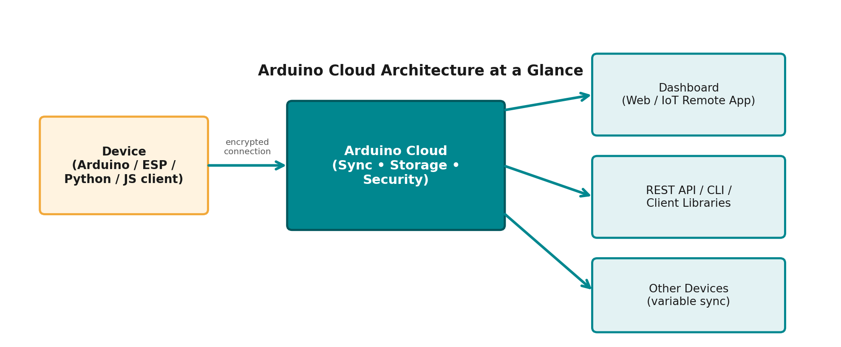

Who is it for?
- Hobbyists and makers building home automation, weather stations, or personal gadgets.
- Students and educators using shared classroom spaces to teach IoT and electronics concepts.
- Small businesses and enterprises prototyping and scaling connected products with fleet management and role-based access control.

2. Core Concepts
Arduino Cloud is organized around a small set of building blocks that make it easy to reason about a project, even as it grows in complexity.

Things
A "Thing" is the central object in Arduino Cloud. It represents a physical device (or a virtual one) and holds the list of variables that device will read from or write to. Each Thing is linked to a specific board and network configuration.

Cloud Variables
Cloud variables are the data points exchanged between a device and the cloud, for example a temperature reading, a switch state, or a motor speed. Arduino Cloud automatically generates the code needed to keep these variables synchronized between the device and the cloud backend, and even between multiple devices, without the developer having to manage the networking logic manually.

Dashboards
Dashboards are drag-and-drop interfaces built from widgets (gauges, charts, buttons, sliders, maps, and more) that visualize and control the variables in a Thing. Dashboards can be viewed on the web or through the free IoT Remote mobile app, so a project can be monitored or controlled from anywhere.

Cloud Editor
The Cloud Editor is a browser-based code editor for writing and compiling device firmware, so no local IDE installation is required. Code can be customized beyond the auto-generated template, and updates can be pushed to devices over the air.
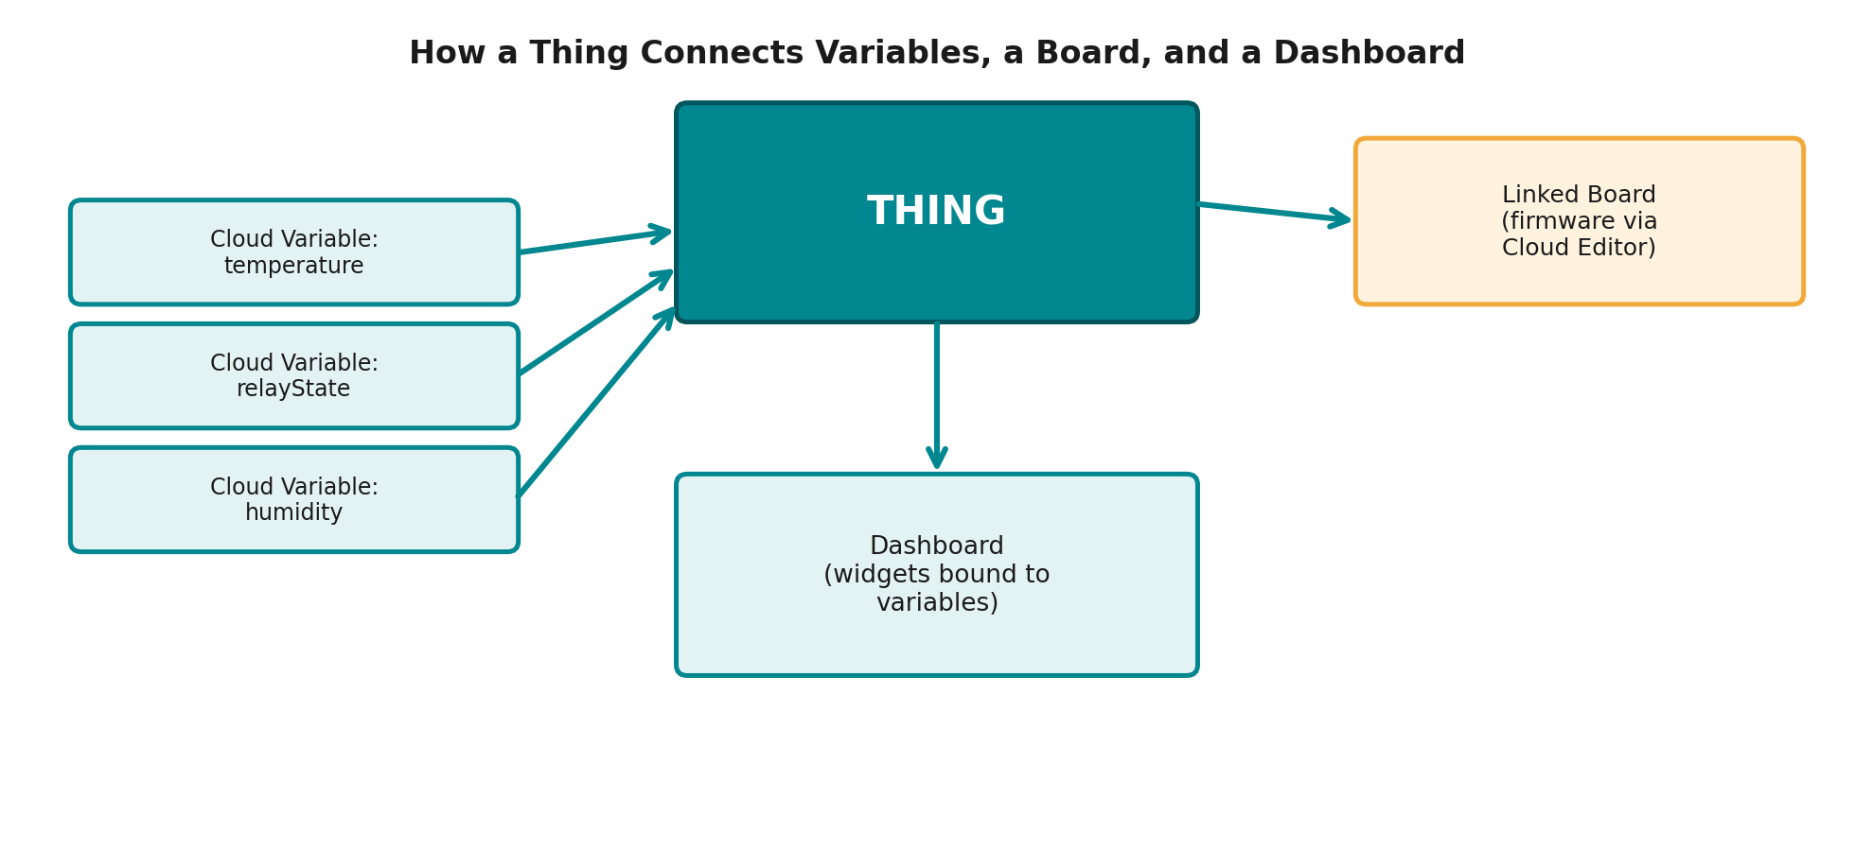

3. Key Features
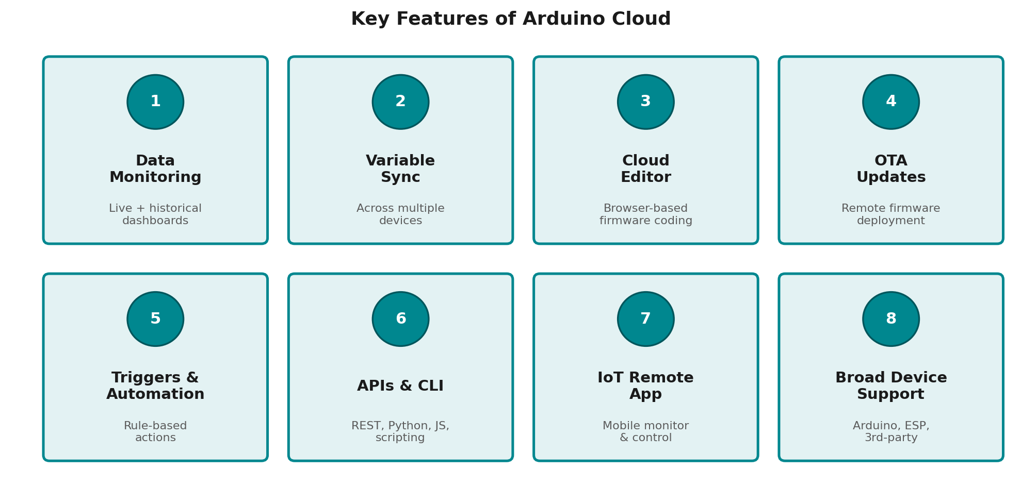
- Data monitoring: view live and historical sensor data on customizable, widget-based dashboards.
- Variable synchronization: automatically sync variables across multiple devices.
- Cloud Editor: write, compile, and upload firmware directly from the browser.
- Over-the-air (OTA) updates: push new code to deployed devices remotely.
- Triggers and automations: run scripted actions when variable conditions are met.
- REST API, CLI, and client libraries: Arduino/C++, Python, and JavaScript/Node.js clients, plus a command-line tool for scripting and mass device management.
- IoT Remote app: a free mobile app for monitoring and controlling dashboards on the go.
- Broad device support: official Arduino boards, ESP-based boards, and third-party devices speaking Python, MicroPython, JavaScript, or Node-RED.

4. How Arduino Cloud Works
Setting up a project generally follows the same workflow, regardless of the type of device or the complexity of the application.
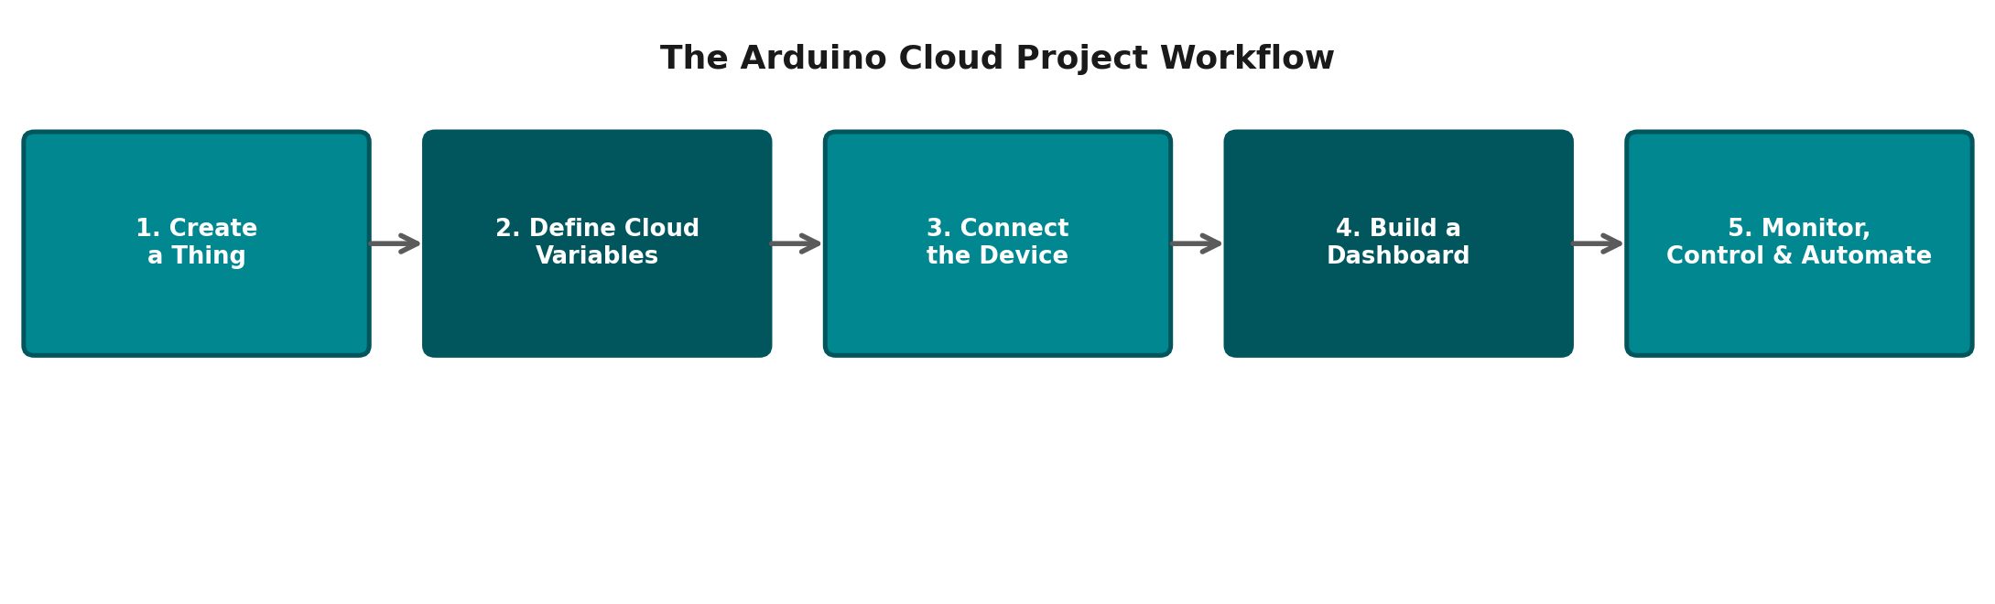

Step 1 — Create a Thing
Start by creating a Thing in the Arduino Cloud console and selecting the board that will be associated with it. Arduino Cloud recognizes most official and many third-party boards automatically.

Step 2 — Define Cloud Variables
Add the variables the project needs (for example, a floating-point "temperature" or a boolean "relayState"). Each variable can be set as read-only, write-only, or read-and-write, and given an update policy, such as syncing on change or on a fixed interval.

Step 3 — Connect the Device
Arduino Cloud generates a code template with the network and variable-sync logic already in place. The Cloud Editor can then be used to add custom sensor or actuator logic, and the sketch is compiled and uploaded directly to the board, either over USB or over the air.

Step 4 — Build a Dashboard
Widgets are dragged onto a dashboard canvas and linked to specific Thing variables. A single dashboard can pull in variables from multiple Things, which is useful for projects that span several devices, such as a multi-room environmental monitoring system.

Step 5 — Monitor, Control, and Automate
Once live, data flows automatically between the device and the cloud. Historical data is stored and can be exported, triggers can fire automated actions based on variable values, and the project can be monitored or controlled remotely through the web dashboard or the IoT Remote app.

Security
Arduino Cloud uses encrypted connections between devices and its backend, and Arduino states its Cloud services are ISO 27001 certified, an information-security management standard. For business use, the platform also adds role-based access control (RBAC) so administrators can manage which team members can view or modify devices and data.
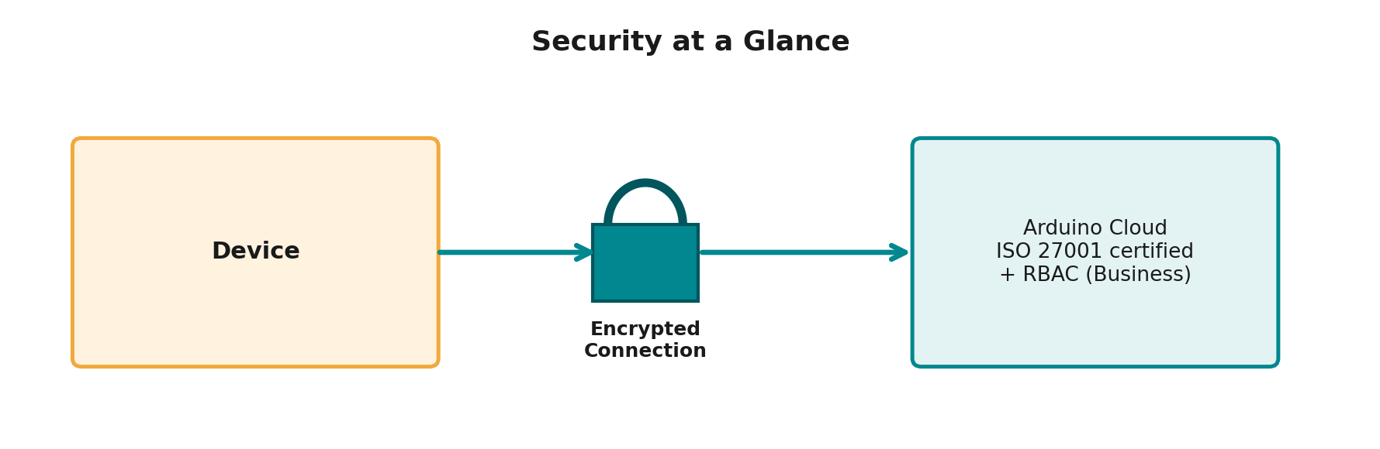

5. Plans and Editions
Arduino Cloud is offered as a tiered product, so individuals, classrooms, and companies can pick a plan that matches their scale.
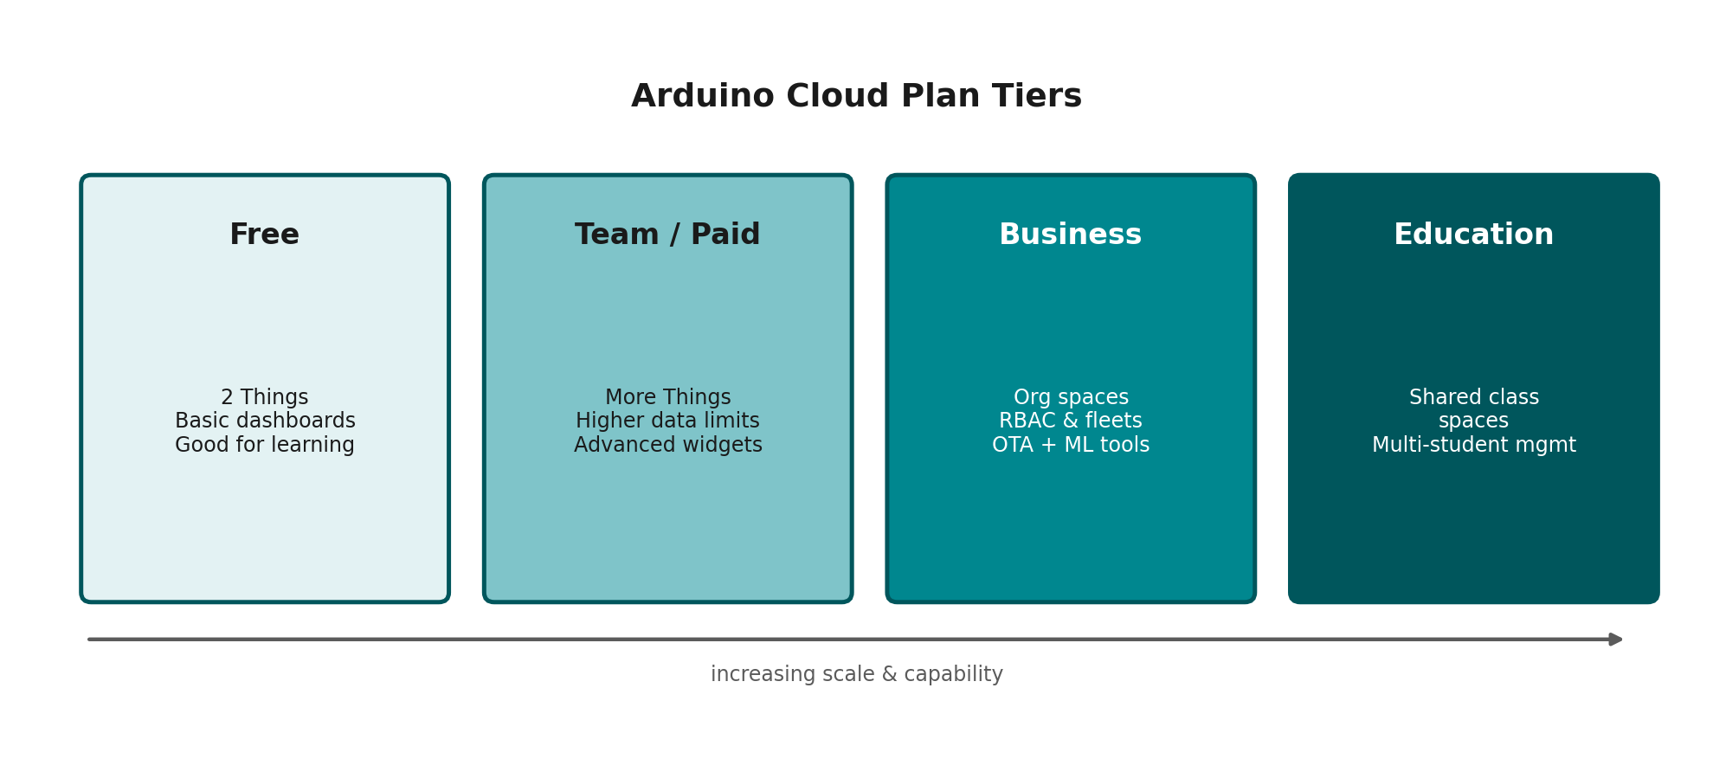

Free Plan
A free tier lets newcomers get started with a small number of Things (Arduino states the free plan includes two Things) and basic dashboard functionality, which is enough for personal projects and small experiments.

Paid / Team Plans
Paid plans raise the limits on the number of Things, the amount of data processed per day and per month, and unlock more advanced dashboard widgets, making them suitable for more ambitious personal or small-team projects.

Arduino Cloud for Business
The Business tier is aimed at companies building and scaling connected products. It adds Organization spaces so multiple projects can be managed separately, role-based access control for sharing with unlimited users, device fleet management with filtering, grouping, and tagging, secure high-throughput data ingestion, and support for maintaining Linux-based devices such as the Portenta X8 with containerized application deployment and differential over-the-air updates. It also includes low-code tools for training predictive machine-learning models directly on collected IoT data.

Arduino Cloud for Education
Education-focused features include shared spaces for classrooms, allowing an instructor to manage devices and dashboards across a group of students in one organized environment.

Recent Platform Updates
In April 2026, Arduino rolled out a redesigned Thing Page intended to consolidate related settings into a single view rather than requiring users to navigate between several tabs, along with a platform-wide dark theme and the ability to undo accidental deletions.

6. Common Use Cases
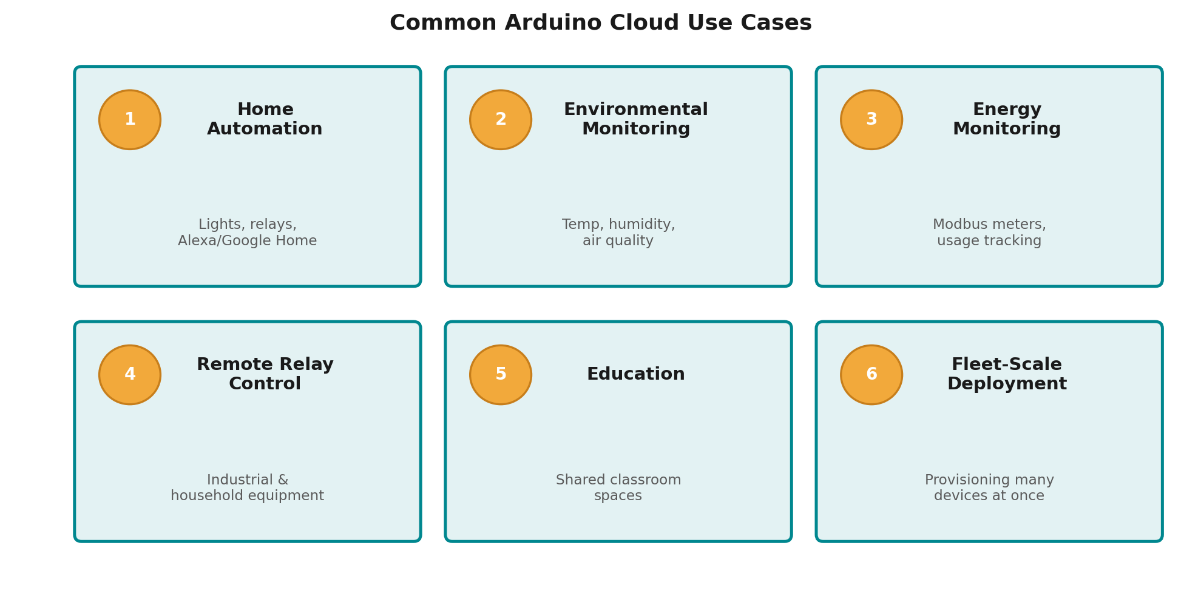
- Home automation: controlling lights, relays, and appliances remotely, including integration with Google Home and Amazon Alexa.
- Environmental monitoring: tracking temperature, humidity, air quality, or soil moisture across one or more locations.
- Energy monitoring: reading utility or Modbus-based meters to track energy consumption over time.
- Remote relay and equipment control: switching industrial or household equipment on and off from anywhere.
- Education: teaching IoT, electronics, and programming concepts using shared classroom spaces.
- Fleet-scale product deployment: businesses provisioning, updating, and monitoring large numbers of connected devices in the field.

7. Getting Started
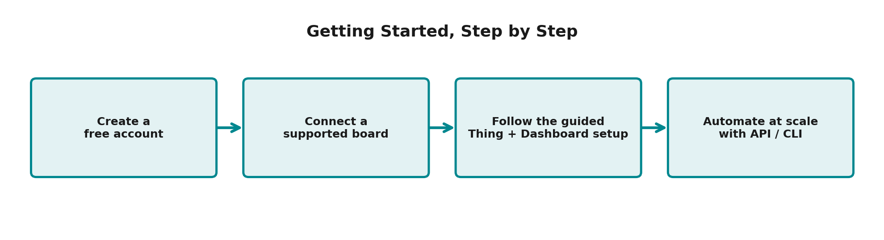
Getting started with Arduino Cloud typically involves creating a free account, connecting a supported board, and following the guided setup to create a first Thing and dashboard. Arduino's documentation site provides walkthroughs for the console, board-specific setup guides, and language-specific client library documentation for those who want to connect devices or applications written in Python or JavaScript/Node.js rather than using an Arduino board directly.
For projects that need to move beyond the graphical console, the REST API, command-line interface, and client libraries make it possible to automate device provisioning and management at scale, which is particularly useful once a project grows from a single prototype into a fleet of deployed devices.

8. Conclusion
Arduino Cloud lowers the barrier to building connected hardware projects by handling the recurring, non-trivial parts of IoT development, secure connectivity, data synchronization, storage, and visualization, so that makers, educators, and businesses can focus on the parts of their project that are actually unique. Its tiered plans and dedicated Business and Education offerings mean the same core platform can support a single hobbyist board on a desk as well as a fleet of devices deployed in the field.

PART II

PLC IDE
Integrated Development Environment for Programmable Logic Controllers
An overview of what a PLC IDE is, its interface, supported programming languages, development workflow, and debugging tools.

1. What Is a PLC IDE?
A PLC IDE (Integrated Development Environment) is the software application engineers use to create, test, and maintain the control programs that run on a Programmable Logic Controller (PLC). It brings together everything needed for one project — program editors, a compiler, a simulator, and tools to connect to and monitor the physical controller — inside a single application.
Rather than working with separate, disconnected tools, an engineer uses the IDE to design logic, check it for errors, download it to the hardware, and then watch it run in real time, all from one workspace. Most modern IDEs are supplied by the PLC manufacturer (for example Siemens TIA Portal, Rockwell Studio 5000, or CODESYS) and are matched to that manufacturer's controller hardware.

Core Responsibilities of a PLC IDE
- Program creation — writing control logic in one or more standardized languages
- Configuration — defining the PLC model, I/O modules, and communication settings
- Compilation — translating the program into code the PLC can execute
- Simulation — testing logic safely before it touches real equipment
- Deployment — downloading the finished program to the controller
- Diagnostics — monitoring, debugging, and troubleshooting a running system
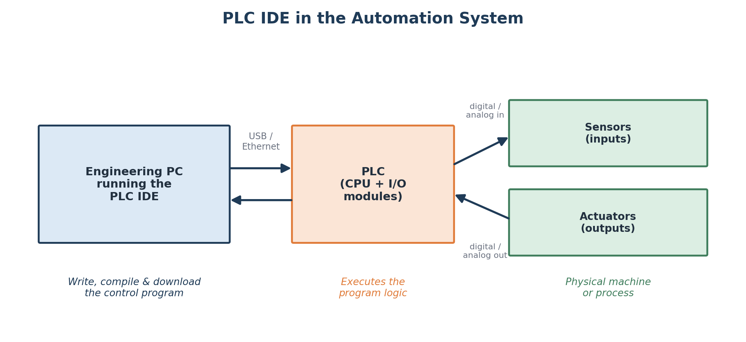
Figure 1. The PLC IDE's place in the wider automation system.

2. The IDE Interface
Although every vendor's IDE looks a little different, almost all of them arrange their workspace around the same core regions. Understanding this layout makes it much faster to pick up a new IDE, since the underlying concepts transfer even when the exact menu names change.

Key Interface Regions
- Menu bar and toolbar — quick access to file operations, compile, download, and run/stop controls
- Project tree — a hierarchical view of the PLC configuration, program organization, tags, and I/O mapping
- Program editor — the main canvas where logic is written, in ladder, function block, text, or chart form
- Instruction / function block toolbox — a searchable palette of built-in instructions to drag into the editor
- Output and watch window — compiler messages, cross-references, and live variable values
- Status bar — connection state, online/offline mode, and controller scan time
Because the project tree, editor, and toolbox are all visible at once, an engineer can browse the program structure, place a new instruction, and check its parameters without switching between separate applications.
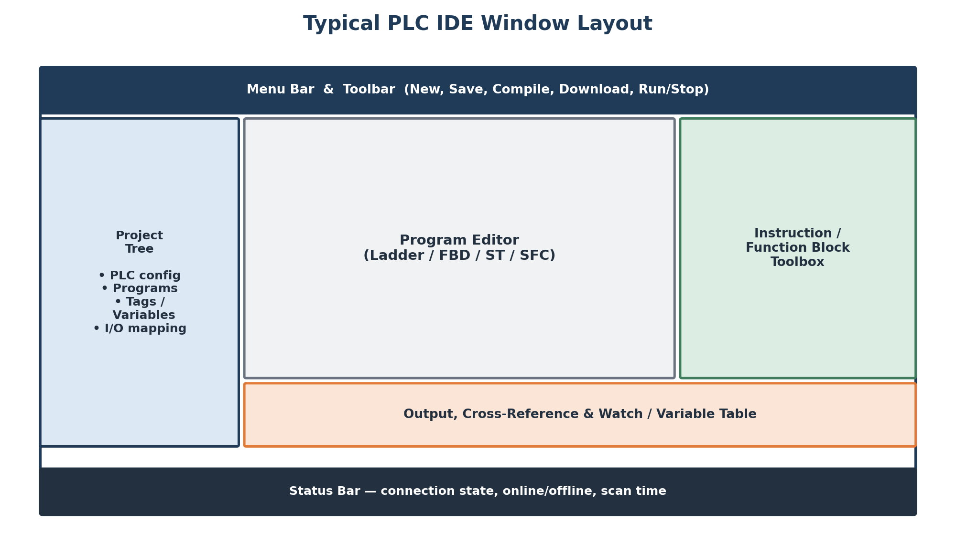
Figure 2. A typical PLC IDE window layout.

3. Programming Languages
Most PLC IDEs implement the five programming languages defined by the IEC 61131-3 standard. Supporting a common standard means logic — and the engineers who write it — can move between different manufacturers' hardware with a much shorter learning curve.

The Five IEC 61131-3 Languages
- Ladder Diagram (LD) — a graphical language resembling relay wiring, widely used for discrete/on-off logic
- Function Block Diagram (FBD) — graphical blocks connected by lines, well suited to signal-flow and process logic
- Structured Text (ST) — a high-level text language similar to Pascal, useful for math-heavy or complex logic
- Instruction List (IL) — a low-level, assembly-style text language (largely legacy in newer IDEs)
- Sequential Function Chart (SFC) — models a process as steps and transitions, ideal for sequencing operations
Many projects mix languages: SFC to organize the overall sequence, ladder for simple interlocks, and structured text for calculations — all inside the same IDE and the same program.
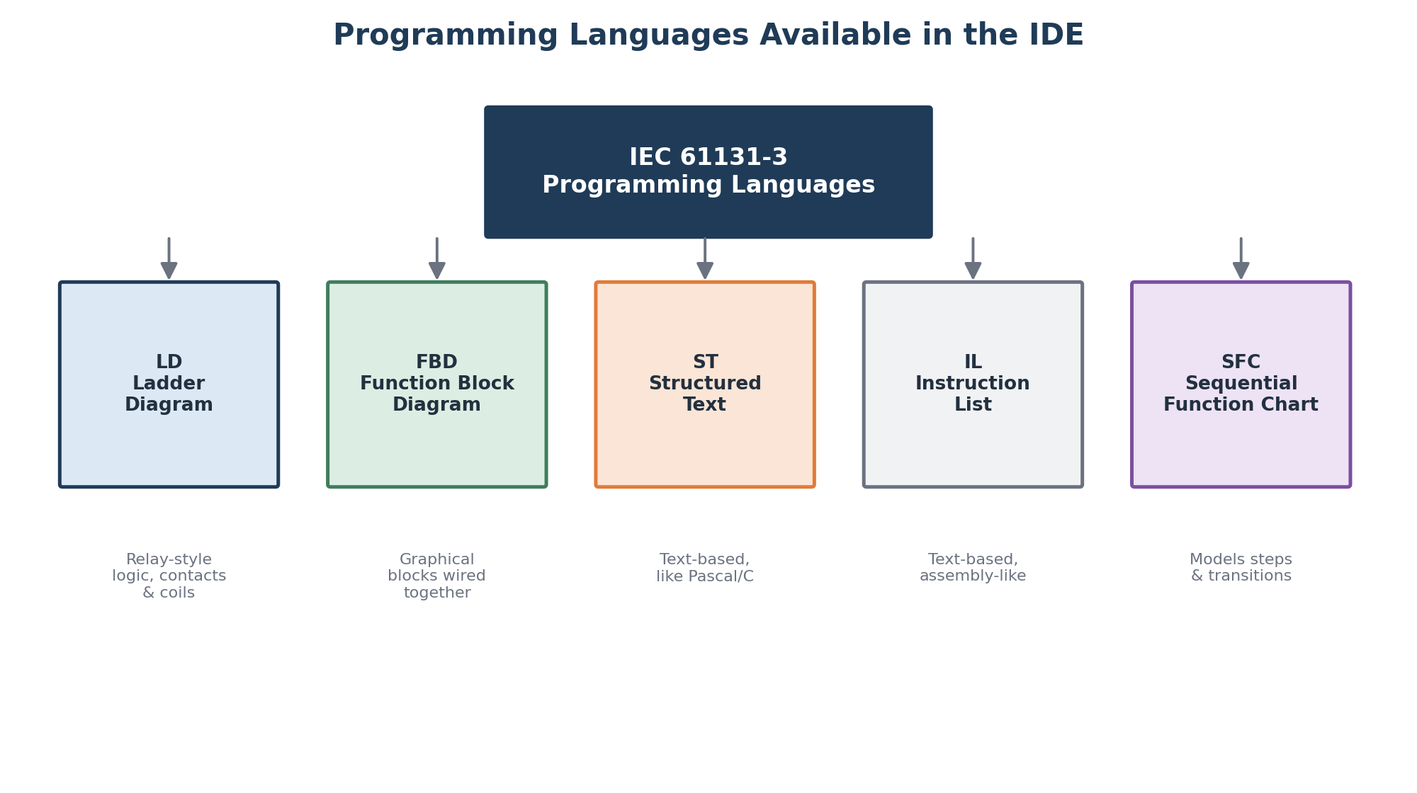
Figure 3. The IEC 61131-3 programming languages offered by the IDE.

4. Development Workflow
Building a PLC program follows a fairly consistent cycle inside the IDE, moving from writing logic through to running it on real equipment. The steps below repeat as often as needed while the program is refined.

From Idea to Running Program
- Write / edit — build or modify the control logic in the chosen language
- Compile and check errors — the IDE translates the program and flags syntax or reference problems
- Simulate offline — test logic against a virtual PLC before any hardware is involved
- Download to PLC — transfer the compiled program to the physical controller
- Debug and monitor online — watch the program execute with live values and highlighting
- Run in production — the finished program controls the real machine or process
If simulation or online debugging uncovers a logic error, the engineer returns to the editor, fixes it, and repeats the cycle — this feedback loop is what makes the IDE, rather than a plain text editor, the right tool for the job.
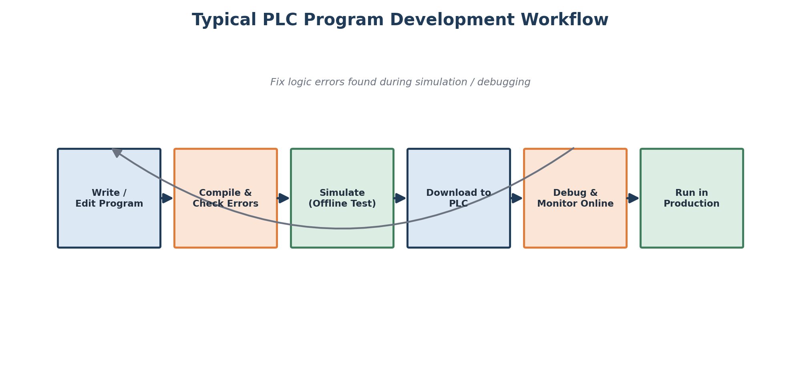
Figure 4. The typical PLC program development workflow.

5. Debugging and Monitoring Tools
Once a program is downloaded, the IDE can connect to the PLC in "online mode." In this mode the editor no longer just shows the written logic — it reflects what the controller is actually doing, scan by scan, which is essential for commissioning and troubleshooting.

Common Online Diagnostic Tools
- Live ladder/FBD highlighting — power flow and active rungs are shown in color as the program executes
- Watch or variable tables — a list of tags with their current values, updated continuously
- Breakpoints and single-step execution — pause the program or step through it one instruction at a time
- Force / override — temporarily set an input or output value to test behavior independent of the field wiring
These tools let an engineer see exactly why a machine is behaving unexpectedly — for example, spotting that an interlock condition is not being met — without having to guess or physically probe the wiring.
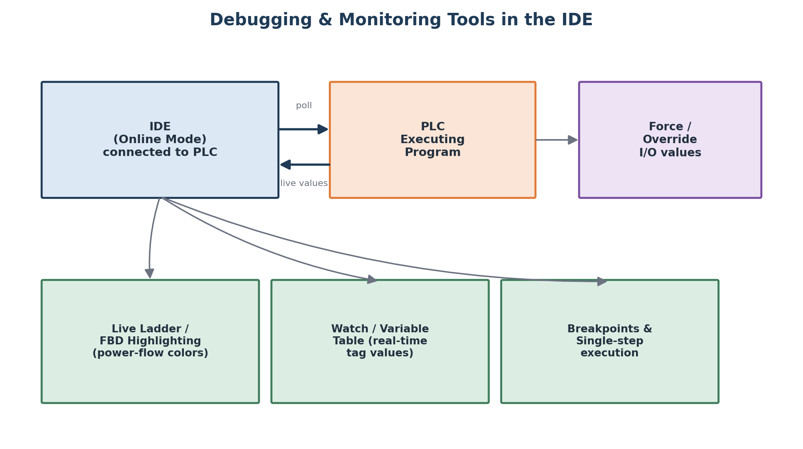
Figure 5. Debugging and monitoring tools available in online mode.

